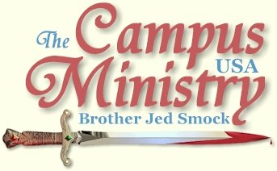
Brojed.org
brojed@aol.com
cell 573-999-0346
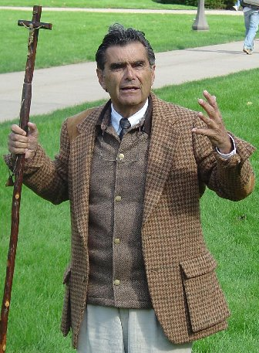

THE SLAVERY ISSUE IN THE BIBLE

University of Iowa, October 5, 2009

I started preaching on the Pentacrest at 11:20 AM. I gathered a small crowd which gradually built up sometimes to over 100. Brandon dominated the questions for the first hour. Generally, he had good questions, which allowed me to make points concerning the nature and character of God.

Later in the day I received an email from Brandon, “It was nice talking to you today. I was the guy with the shaggy hair around noon sitting on the grass asking about your drug experiences. I wanted to let you know that I didn't mean to sound contesting when I asked questions. Anyway, I felt like I couldn't get a clear discussion because everybody was shouting and it was sort of hectic. If you'd ever like to have coffee or anything let me know. I'd be very interested in hearing about your life.”

When he left, a fellow with an attitude, who must have been reading from the writings of the atheist Sam Harris, objected to the Bible for condoning slavery. It was evident to me that this man had not actually read the Bible, but only a few isolated passages. Atheists do not make a distinction between Jews who could become indentured servants for six years then freed the seventh year, and pagans who could be enslaved for a life time.

This skeptic claimed that a man could sell his daughter as a sex slave according to the Book of Exodus. Exodus 21:7-8 does speak of a father who might sell his daughter as a “maid servant” to a prosperous man to be his wife or to be his son’s wife. If he was to be the son’s wife, the master was to treat her as a daughter. These laws protected the girl from sexual exploitation, and gave her the opportunity to improve her station in life.

He also objected to the passage in Exodus 21 where if a man beats his servant to death, the master is to be punished with death; however, if the servant survives a day or two the master shall not be punish because the servant is his property. I suppose that the assumption is that if the servant survives for a few days it was not the master’s intent to murder but to discipline. So it is enough punishment to the master that he has lost valuable property.

Slavery was not part of God’s original plan for man; but when man sold himself to the slavery of sin and idolatry, God used chattel slavery as a form of judgment. Men can forfeit their right to freedom though sin. God’s man, Moses, was the greatest slave emancipator of history. Slavery is only a sin if it goes beyond God’s regulations of the institution. The Bible is not written primarily to promote outward social change. It promotes change from within by motivating men to love their fellows, even their enemies.

Critics of the Bible position on slavery are usually statist, who would make us all slaves of the socialist state. They sell out their own freedom; because they do not want to take on the responsibility of providing their own food, clothing, shelter and health care. Slaves living under Biblical regulations, compared to the slaves of pagans like the Egyptians and Romans, were treated relatively well. They may well have had better provisions than many freemen. Statists prefer the promises of the security under socialism over the high risks involved in freedom. Many Americans are forfeiting their freedom by their refusal to govern themselves in the light of “the laws of Nature and Nature’s God.” Such people are not truly American; they tend to be internationalists, like Master Obama.

Most of college students have no appreciation of freedom. They have freedom confused with license. They would make us all slaves of Master Obama. Personally, I do not care to become a part of Obama’s commune with it social planners from the Democratic Party.

The students were generally civil, although one female passed behind me and spit on me. I did not realize it at the time. But a student informed me later, and said what she did was wrong. There was only one open homosexual in the crowd. He promised me that his cohorts would be coming out later. However, I had to stop the preaching at 3:30. I expect the sodomites will be out in force with signs before I finish with this campus.
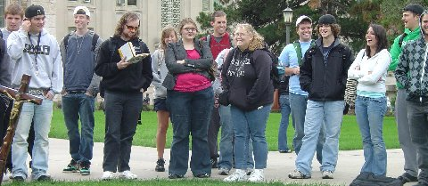
The Congregation


SISTER CINDY JOINS ME FOR THE DAY

University of Iowa, October 6, 2009
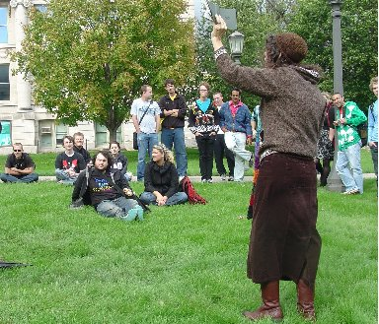

I started speaking on the Pentacrest at 12:20. It was cloudy and windy; the sun was supposed to have come out by 12, but that was only briefly. Despite the poor weather conditions, I gathered a crowd which average around 50-75 for most of the afternoon. About 1, a polite policeman came out and asked me to move to the center of the Pentacrest, so as not to disturb classes.

The highlight of the day was Cindy driving about 5 hours up from Columbia to join me for the day and return in the morning. Cindy and I alternated after she arrived at 2:30. The wind gusted up to 40 miles at times and it seemed to become colder at the afternoon progressed; and we never did see much sun. Nevertheless, our congregation was faithful to stay with us.

The students seem to especially enjoy our preaching on this campus. We have had great meetings here in recent years. The students requested that I sing the gay song. I feigned an unwillingness to sing the song, saying, “That song is very offensive to the gay community.”

“You sang it last year,” several in the crowd said.

“But I have grown since last year. I am trying to be more sensitive to the gay community. We need to remember that homosexuals are people too. They also have feelings.”

After making them entreat me to sing the song, I finally said, “I can only sing the song with the permission of the gay community.”

The gay guy who was in the crowd yesterday said, “We want you to sing the song.”

“Do you promise that you will not commit suicide if I sing the gay song?”

“I promise,” he replied.

“OK, I will sing the song. I dedicate it to the gay community.”

The students actually applauded after I sang.
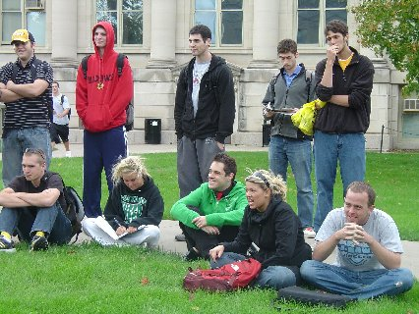

There were many more serious times throughout the afternoon. I had an opportunity to expound on the atonement in response to a skeptic who continually asked, “Why did God have to torture Jesus before he could forgive our sins? God is supposed to be omnipotent. He ought to be able to forgive sins without torturing his son.” Despite my explanation that wicked men abused Jesus, not his father, he still used the language of God torturing Jesus. He then asked, “Why was Jesus only dead for three days? Why not longer if God wanted to demonstrate his love?”

I answered, “Jesus defeated sin on the cross, but he needed only three more days to complete his work of conquering Satan, Death, Hell and the Grave and lead Old Testament saints out of their captivity into Heaven through his Resurrection.”

Both Cindy and I had the opportunity to do one on one witnessing, while the other one was carrying the preaching load.

After 5 PM a light rain started. Still we had about 20 listening. I finished with my parable which illustrates that we must seek God with our whole heart if we are to find him.
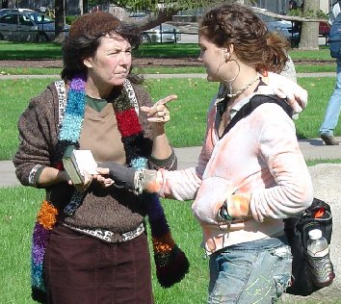
Sister Cindy gets a note about love from a hippie girl

I AM AN INSTITUTION NOW

University of Iowa, October 7, 2009,

Around noon, I set up my chair on the Pentacrest to wait for the 12:20 break. As I was waiting a boy asked, “Where’s the crowd.”

“I haven’t started preaching yet,” I replied.

An older gentleman arrived and greeted me, “Brother Jed, I heard you at the University of Illinois in 1974.” That is the year I started evangelizing the campuses full time. He also remembered my associate of those days the late Brother Max Lynch.

He turned to the boy and a few others who had gathered by this time. “Do you know to whom you are talking? This is Brother Jed; he has probably been on every university in the country. He is an institution, a legend.”

An institution is someone who is firmly associated with a place. After 35 years I am resolutely associated with the colleges and universities of America.

The gentleman is now a computer professor at Iowa. Before he left, he said, “Brother Jed, I don’t believe what you teach; but I appreciate the tradition you have created.”

Each day, many of the same people have been have gathered hour after hour. However, today I had some unrequested help. A middle aged lady began to argue with the students concerning homosexuality. For a while she gathered a group of about a dozen around her. She also interrupted me twice to exhort the crowd and to give an altar call. Once she asked anyone to come forward who would believe God if he would reveal himself. One fellow with whom I had been having a lively exchange came forward and she prayed for him. Afterwards, he said nothing happened. I explained that it requires more than asking, one must seek and knock and be willing to open his eyes to what God has already revealed of himself through the creative order and through conscience.

Later the woman interrupted to read and expound briefly on John 3 and gave another altar call. It was evident to me that those listening were not under enough conviction to respond to an altar call; but the woman was bold in her witness. She then started a conversation with a sinner girl, who had been in the audience for a time.

The mocker of yesterday, who accused God of torturing his son, was with me again today for most of the afternoon. His line today was that Jesus and his followers are masochists. I explained that a masochist is one who takes pleasure in suffering, pain and humiliation.

Christ despised the shame of the cross; but he endured the cross for the joy that was set before him. We Christians do not suffer for the sake of suffering; but we suffer for righteousness sake and our willingness to uncompromisingly stand for Truth. As Jesus bore the sufferings of man’s sin; we too have to suffer and bear the sins of the world. For the church is his body on earth. As he suffered, we will suffer; and we endure and rejoice in our suffering for the joy that is prepared for us.

I preached until 5:30. Brett, a staff member from Intervarsity, asked to walk with me to the parking lot. He said that he had been in prayer yesterday and thought the Lord was telling him to rebuke a campus preacher and preach the real gospel. Then he heard Cindy and me, listened for a while and determined that we were bringing forth lots of truth and that our witness opened up opportunities for him to witness. He said the he hoped to be able to meet with me tomorrow to talk more. Perhaps we will be able to work something out.
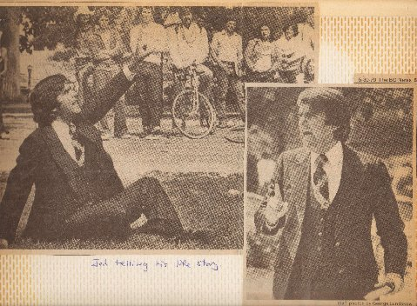
Bowling Green State University 1979
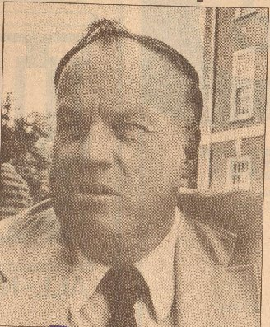
Brother Max. Lynch
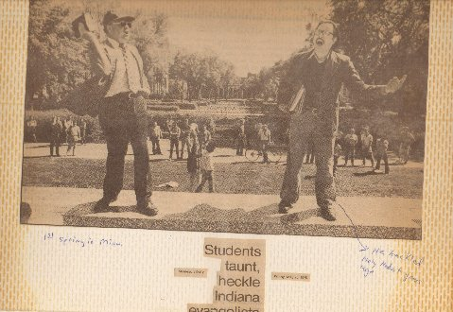
Brother Max, University of Minn. 1979
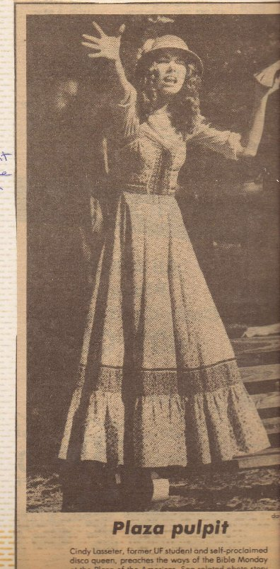
Sister Cindy University of Florida, 1979
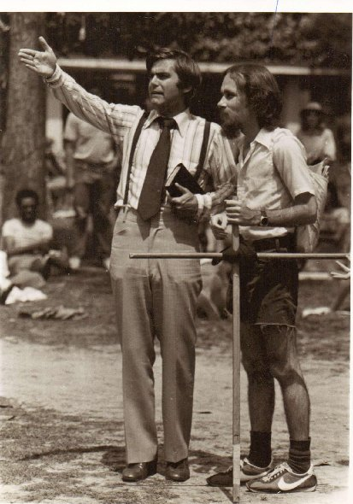
Bro. Jed and infamous heckler, "Reprobate" at UF 1980
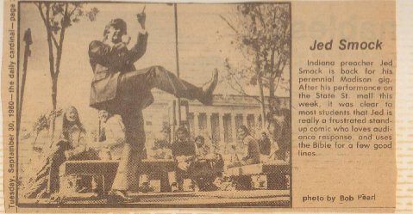

THE INTERVARSITY STAFFER

University of Iowa, October 8, 2009

Today it was raining all morning. I arranged to meet with Brett, a staff member from Intervarsity, which is one of the prominent campus ministries across the nation, at 11:30 AM in the Student Union. He informed me that he had only been on campus for two months; and that he is part of a team to reestablish Intervarsity at the University of Iowa. He had questions concerning holiness and my calling to the campuses. I told him my story. We also went over key verses in 1 John. Yesterday, I gave him a copy of Walking in the Spirit, so he was familiar with my position that Roman 7 does not refer to the Christian experience. He was not argumentative nor did he defend sin, nor speak disparagingly of my methods. He expressed interest in preaching himself; but he was concerned that he might incur problems from the administration in reestablishing the organization. I suggested that if he preached open air, he also would likely have challenges from the higher ups in Intervarsity.

I noticed that it looked like it had stopped raining by 12:15; so I suggested that unless he wanted to continue our talk that I would start preaching. He still had some things he wanted to talk over; so I considered it profitable to continue our fellowship and the weather still looked unsure. He brought up the question as to whether a believer’s sin would separate him from God. I knew that Intervarsity believed in eternal security, so I avoided that controversy by saying, “Cannot we agree that sin grieves and offends God, which should be our primary concern instead of the salvation of our soul?” He agreed. Sometimes by arguing a point which Christians have disagreed upon through the Church age, we can create a seal against conviction of sin. Our main concern should not be our own salvation, but having a wholesome fear of doing anything which would displease our loving Savior.

Brett wanted to watch how I started my preaching, so at 1:15 I began proclaiming the Word on Cleary Walkway. I thought it that would be a better location today than the Pentacrest, since tents were set up on that location for the football weekend; and I knew that the grass would be wet there. However, at the break I did not get a crowd, so I sat on a bench with Brett to talk while holding my sandwich board sign with the list of sins.

Liz approached us and asked, “Why is feminism on the sign?” My answer developed into a discussion on the role of women. Liz was not contentious but thoughtfully considered the Biblical position of a wife submitting to her husband. She filled out a contact card for Brett. I encouraged her to meet for Bible study with him.

At the next break I started preaching again. A combative atheist with whom I had had some debate on previous day approached me. He challenged me to defend the faith. He objected to my use of the Bible to defend Christianity. I instructed him on epistemology, which the branch of philosophy that considers what we know and how we know it.

I explained that appeals to authority are a legitimate approach to knowledge and that most everything we claim to know is based on authority. I said, “When I appeal to the Bible, I am not appealing to one book, but 66 books, written by at least 40 different writers over a period of about 1500 years. The fact that these men are all in agreement on the basic issues of life is at least evidence for the validity of the Bible and the claims of Christianity.”

He also objected to my appeal to experience and the testimony of other Christians to validate Christianity. I defended, “Common experiences of reasonable men are also evidence to defend truth.”

Furthermore, I explained, “A third epistemology is, ‘Are one’s points reasonable?’ I challenge you to show any logical inconsistencies in my arguments.”

However, like most atheists, this man did not want to reason or really listen. He was not looking for reasons to believe, but desperately wrestling against and resisting the truth. Frantically, the atheist will try to convince others not to believe; since the faith and holiness of reasonable Christians is in itself evidence for the truth of Christianity (Hebrews 11:1).

Meanwhile, our heated debate had drawn other students. Someone brought up that miracles are unreasonable. I explained, “It is not unreasonable to believe that a God who set up the laws of physics could temporarily supersede these laws and perform a miracle; it would be reasonable to assume that he would from time to time in order to let people know that he is still present in and ruling his universe.”

“Christianity is unreasonable because it contradicts evolution,” someone exclaimed.

Alas, trying to reason with these students can be a challenge. Few of them know the laws of logic and even fewer of them apply them in their arguments. Mostly, they just emote, emote and emote. And then, they emote some more.

Eventually, someone asked me a question concerning sexual behavior. I went along with the change of subject because few students can relate to the more philosophical and apologetic discussions for very long. And I wanted to build up the crowd.

There was a girl in the crowd who said she was guilty of a number of the sins on my sign. “I am a seducer,” she said. The girl was pretty and did have a personality; so she was probably quite successful in her seductions. She had been brought up a Catholic but now no one in her family was practicing Catholicism. I asked, “Why, what happened?” I don’t know,” she replied. At one point Brett talked to her for a considerable amount of time. I hope that he got her contact information; because I perceived that her heart softened throughout the afternoon.

I stopped preaching at 4:30. I considered it a profitable day. I was concerned that it would be a washout. My time with Brett was well spent. I believe that the Lord showed him much. Too bad there are not more from Intervarsity or Campus Crusade for Christ or the other Christian organizations who will actively take advantage of the interest which we stir, instead of often zealously opposing our preaching or responding with indifference. If we could get the Christians organizations behind us, we could have a revival on campus. However, the revival would have to start with these people getting rid of their sin excusing doctrines, like the sin nature that they believe a Christian has until his physical death. It is difficult for them to get behind our sin condemning preaching when they promote sin excusing doctrines.


THE BATTLE CRY

University of Iowa, October 9, 2009

Last night I went to a mission’s conference at Calvary Evangelistic Center in Independence, MO. Pastor William Hill and I go back to the 70’s.

In the morning I drove back to Iowa City. I changed my plans and decided not to go unto Nebraska next week since the weather does not look good for there. I stopped at the University of Iowa to preach at the 11:20 break on Cleary Walkway. It was cloudy and only in the high forties when I started. Consequently, only four students stopped. They were “fans.” One of them wanted his picture taken with me which he later posted on facebook. They only stayed for about 15 minutes.

I briefly toured the museum of natural history which is with is on the Pentacrest. I pondered their window display on evolution showing man as descended from fish. It is truly amazing that the world has blindly accepted this evolutionary model. Is this the strong delusion that God has sent in these last days that men should believe such an absurd lie as all species having a common ancestor? I thought of the vanity and wickedness of these professors lives, who have offended the youth by teaching this nonsense which makes man so insignificant and takes away the meaning of life.

I was determined that if I did not get a crowd at the 12:20 break, I would drive on home. But quickly people gathered. The gathering was never more than 25; but I thought that pretty good considering it was cloudy and barely fifty degrees, plus it was Friday of a big football weekend.

The highlight was an exchange with two Moslems in which I was able to relate a history of the First Crusade when Christians liberated the holy land from Moslem rule. Unlike most Christians, I do not apologize for the crusades. [I am not Obama]. I consider the Crusaders as honorable, although one does have to acknowledge some atrocities that happened, as it always does in any warfare. I would that we had the crusader spirit in Christendom today, both spiritually and militarily. I have got it spiritually and dear Evangeline is doing her military duty against Islamic Jihadists.

At issue with these two Moslems was the usual: the Trinity and the Sonship of Jesus. The really interesting part of the dialogue was when I spoke of man being in the image of God and when I stated that God suffers. They argued passionately against a suffering of God. The Moslems claimed that Allah could not suffer.

I argued that even though the Koran speaks of a loving God there is nothing in the Koran which demonstrates a loving God, like the Biblical God becoming a man and suffering at the hands of his creation. If God does not suffer, then God cannot be a loving God. Our sin brings suffering and grief to God, much like sin in children brings suffering and grief to loving parents. If parents were indifferent to rebellion in children, they would not be loving parents.

I have been meditating the Crucifixion of our Lord this week; I was thinking that the staff crucifix which I carry demonstrates that the Christian calling is a call to warfare. The crucifix is a battle cry. The crucifix lays bare both the great love of our sovereign Lord and the viciousness of our enemy.

I received a letter from a dear old friend this week critical of my carrying of a crucifix, which he called the “popish walking stick.” He wrote that, “Isaiah said, he was ‘marred more than any man’ yet the Catholic crucifix mocks his suffering- no signs of the vicious flogging he endured, no swelling or cuts, no flesh hanging in shreds, even the full color models have only a few drops of blood here and there from the spear, nails, and crown. It appears he might have simply died of a heart attack and been hung up later.

He has a point that crucifixes are usually cleaned up; but it could be argued that the empty cross leaves no impression at all on the cruelty of our enemy and his hatred of our Savior. A theme of my preaching is the suffering of God because of sin. We Christians are to identify with and manifest his sufferings, that we might “complete that which is lacking of the afflictions of Christ in our flesh for his body’s sake, which is the Church (Col 1:24).

Men must see Christ through his Church. The crucifix I carry is a symbol, a visual aid and reminder of the suffering of our Lord. But as we take a stand against sin the world will crucify us through mockery and ridicule and rejection. According to Isaiah our Lord was “despised and rejected of men.”

Jesus said, “The servant is not greater than his lord, If they have persecuted me, they will also persecute you (John 15:20).

Our resurrected Lord asked Saul on the Damascus road, “Saul, why do you persecute me?”

To think that man is able to persecute God boggles the mind of Moslems and even many Christians, who hold to the doctrine of the impassibility of God as expressed in the Westminster Confession of Faith which says that God is “without passions, immutable.”

Men nail Jesus to the cross again and “crucify to themselves the Son of God afresh, and put him to an open shame,” when they fall away from the faith. Many students daily confess to having been brought up in the church and even confirmed in the faith; but then they come to college and they deny “the Lord who bought them.” Shame! Shame! Shame!

Who will rise up and defend our Lord, and the Church of God, which he hath purchased with his own blood? Who will resist unto blood striving against sin, as did our Savior? Who is willing to deny themselves daily and take up his cross and follow our Lord in his passion?

I stopped preaching at 2:30, since I had an almost five hour drive home. But before I quit for the day, one of the Moslems apologized to me for coming off as rude.
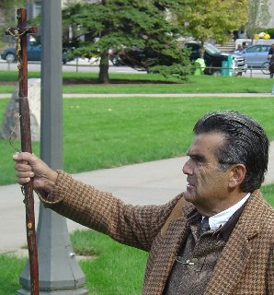

What can you do to help?
1. We need faithful prayer warriors to intercede for souls as well as praying for our health, safety and financial needs. This is vital!
2. As always, we need monetary gifts. We appreciate that some of your budgets are considerably tighter and yet you have continued to give faithfully. May God reward your generosity. Some have had to reduce your giving significantly, but you are still donating what you can. Thank you also. Please know that no gift is ever too small. God accepts them and so do we. If more of you would just send small gifts, it would help us greatly. If any of you do have extra funds and can make up the slack, please do so. We are also trying to find ways to reduce our own budgets. Often saints provide lodging for us when we come to their campus town. If you would like to help in this important way please contact us.
3. Arranging a church or home meeting is a great way to bless the CMUSA. Bro. Jed welcomes the opportunity to meet and minster to new people. He is thankful to address groups both large and small. It is amazing the hearts that God will touch in just a small home meeting. I believe that there are many Christians who would like to support this work on the campuses if they knew about it. Help us get the word out.
4. Finally, invite your friends to receive this journal also. It will make Christianity come alive, increase their faith and keep them revived!
5. Also, if you haven’t read Who Will Rise Up? lately, I encourage you to do so. If you gave your copy to someone and never got it back, you may order a new one from us for a $12 gift to CMUSA. We found a few extra boxes.
You may donate to CMUSA using PayPal by going to our website at Brojed.org or you mail a check to our home office: CMUSA, Bro. Jed smock, 2402 Longview Dr. Columbia, MO 65203

